Dryer and Vents – March 2009
Awhile back I was asked by a few people about having a professional come in to clean their dryer ducts. I had said I didn’t think it was necessary, but after looking into our dryer ducting situations I reconsidered and think it may be a good idea for some. Frank Mets had a problem with his dryer recently not drying completely and whites coming out gray. He cleaned the lint trap, the inside of the dryer, the duct trap and connecting hose but still had the same problem. He had it serviced and they changed out two solenoid valves. Worked fine when disconnected from the vent pipe but he had the same problem when he hooked it back up. He called in a professional flue vent cleaner and with flue brushes and air pressure they removed over a cubic foot of dark gray lint. It now works as good as new. He thought the lint looked burnt but when I examined it, I came up with another thought. If his dryer was plugged as bad as he says, then the gas flame probably wasn’t getting enough fresh air to burn clean. If you starve any flame of air it will not burn completely and create soot. I think the soot was filtered and collected by the lint in the vent piping. This leads to another tip, the vents that are in your laundry room that connect to the attic (not the heat/AC register) are there to supply fresh air for the dryer combustion process. If you close these off and shut the door, the dryer will starve for air. Especially if your hot water heater is in the same room. Dryer venting is not as simple as it seems. The blower motor within a dryer can only push the moist air so far. If you exceed this limit, the dryer will not dry clothes properly and the vent piping can easily clog with lint. The exhaust hood design, the type of exhaust pipe used (smooth metal vent vs. corrugated/flexible metal pipe), and the number of bends in the exhaust piping create friction that slows the air leaving your dryer. Probably most of us had our dryers on an outside wall or in the basement where we lived before. These arrangements allowed for relatively short ducting runs. In the Fairways all the laundry rooms I have seen are in the middle of the house and do not have a wall that is common with the outside. What’s more, a lot of houses have long horizontal runs that add to resistance.
Smooth metal vent pipe and exterior exhaust hoods that have openings of sixteen square inches or more offer the least resistance to air flow. If you have no bends or turns in the exhaust piping, you can place the dryer up to 64 feet away from the exhaust hood. The addition of four 90 degree bends allows you to have only 27 feet of straight pipe in between the dryer, the bends and the exhaust hood. Exhaust hoods with narrow mouths often have only ten to twelve square inch openings. If you use one of these with flexible piping that has four bends in it you can only have fifteen feet of straight piping between the bends, dryer, and exhaust hood!
So, check out your run and if you are more than 25’ or have a long horizontal run of duct pipe I would recommend a professional cleaning at least once every two years.
Because we live in a cold climate it is also recommended to insulate the metal dryer pipe where it enters the attic to where it connects to the roof exhaust hood. Without this insulation, the metal pipe will chill the moist air within the pipe creating condensation. This liquid water will run down the pipe and possibly leak from the pipe joints or show up as a leak under your dryer. High quality reinforced foil duct tape found at heating and cooling supply houses is the best material to use to secure the insulation to the metal piping and the insulation backing. Standard duct tape can fail in the extreme temperatures found in many attic spaces.
Check to see how your dryer vent pipe was fastened together. If the builder used screws, (guess what? He did!) it was a mistake. The screw tips inside the piping collect lint and cause additional friction. Manufacturers and building code officials prefer that you use the reinforced foil duct tape in conjunction with special large diameter hose clamps that squeeze the pipes together.
Note that white vinyl dryer vent hoses are not UL-Approved and are a great way to start fires in your house. The American Household Appliance Manufacturers Association (AHAM) recommends the use of either rigid aluminum or steel duct or spiral-wound aluminum flex hose--NOT the white vinyl hose. For any dryer, but especially gas dryers, white vinyl vent hose should never be used. If yours has this installed on it, replace it ASAP with UL-approved materials.
I got a lot of this information over the web by doing a search on dryer venting. The rest of it I got from my wife who said “It is only common sense dopey.”
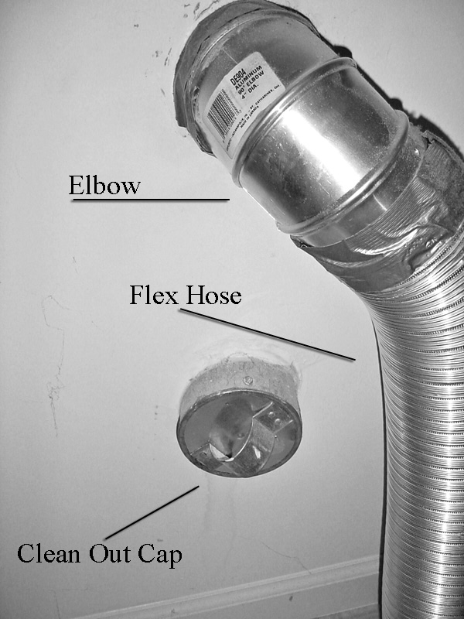
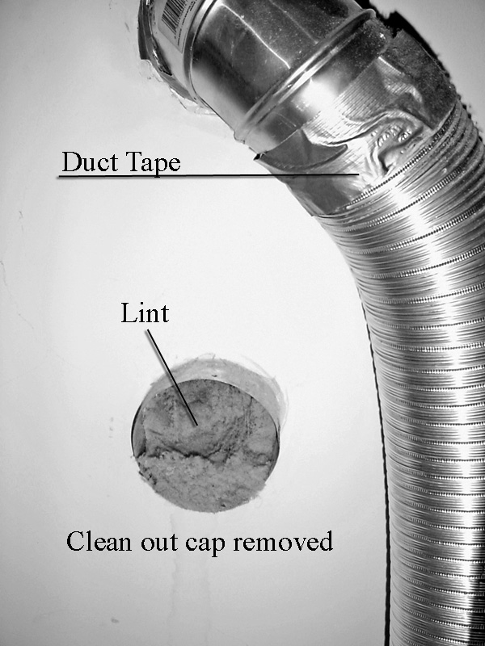
Common sense also tells us to clean out our screens (lint traps) after each load. Every now and then remove them and reach in with your fingers to pull what lint out you can. Then stick the vacuum cleaner with the radiator (remember radiators?)attachment on it into the area and suck out the rest. Once a year pull the dryer out (or have someone do it for you), remove the clean out cap and pull out whatever lint has fallen into it. At this time check your flex hose, connections and condition of the duct tape. In the picture above, the clean-out is doing what it is supposed to do. The lint that has gotten past the screen and into the ducting has settled in the clean-out area and is not blocking the air flow in the duct. However, if it is not cleaned out occasionally it will accumulate enough to block the discharge elbow above it.
This and previous around the house articles can be retrieved on the web at http://www.aaazzz.net/id5.html

